|  |  |
| --- | --- |
| **Exp no: 01**  **Date:** | **INTRODUCTION TO HTML AND CSS** |

**Aim:**

**a.**To create a web page that embeds an image map (such as a campus or country map) and uses:

* Hotspots (clickable regions on the map),
* Frames to display linked content,
* Hyperlinks for navigation.

**b.** To create a single web page that demonstrates the use of all three types of CSS:

* Inline CSS
* Internal (Embedded) CSS
* External CSS

**Algorithm:**

**a.** To create a web page that embeds an image map (such as a campus or country map)

* Start the HTML document with the <html>, <head>, and <body> tags.
* Create frames using the <frameset> and <frame> tags (or use <iframe> if frameset is deprecated).
* Insert a map image using <img> with the usemap attribute.
* Define hotspots on the image using the <map> and <area> tags.
* Use shapes like rect, circle, or poly.
* Assign coordinates and link each area to different pages or targets.
* Link the hotspots to pages that will open inside a specific frame using the target attribute.
* Add navigation hyperlinks as needed to demonstrate page linking.
* Ensure proper naming of frames using name attributes.
* Save the HTML files and open the main HTML file in a browser.
* Test all hotspots, links, and frames for correct navigation and display.
* End.

b. To create a single web page that demonstrates the use of all three types of CSS:

* Start the HTML document using <html>, <head>, and <body>.
* Create content like headings, paragraphs, and divs.
* Apply:
* Inline CSS: Use style attribute directly within an HTML tag.
* Internal CSS: Add a <style> block inside the <head> section.
* External CSS: Create a separate .css file and link it using the <link> tag in the <head>.
* Apply different styles using each CSS method to highlight their differences.
* Save the HTML and CSS files.
* Open the HTML page in a browser to view the result.
* End.

**HTML CODE:**

1. Embedded.html:

<!DOCTYPE html>

<html lang="en">

<head>

    <meta charset="UTF-8">

    <meta name="viewport" content="width=device-width, initial-scale=1.0">

    <title>CSS Styling Example</title>

    <!-- Google Font -->

    <link href="https://fonts.googleapis.com/css2?family=Poppins:wght@300;400;600&display=swap" rel="stylesheet">

    <style>

        /* General Styles */

        body {

            font-family: 'Poppins', sans-serif;

            background: linear-gradient(to right, #4972af, #398dd1);

            margin: 0;

            padding: 0;

            display: flex;

            flex-direction: column;

            align-items: center;

            justify-content: center;

            height: 100vh;

            text-align: center;

        }

        /* Styling for Heading */

        h1 {

            font-size: 2.5rem;

            color: #ffffff;

            text-shadow: 2px 2px 5px rgba(0, 0, 0, 0.3);

            margin-bottom: 20px;

        }

        /* Stylish Paragraph */

        p {

            font-size: 1.2rem;

            padding: 10px;

            background-color: rgba(255, 255, 255, 0.2);

            border-radius: 10px;

            box-shadow: 0px 4px 8px rgba(0, 0, 0, 0.2);

            color: white;

        }

        /* Stylish Box */

        .box {

            background: rgba(255, 255, 255, 0.3);

            padding: 20px;

            border-radius: 15px;

            border: 2px solid rgba(255, 255, 255, 0.6);

            width: 320px;

            text-align: center;

            font-size: 1.2rem;

            color: white;

            box-shadow: 0px 5px 10px rgba(0, 0, 0, 0.3);

            margin-top: 20px;

            transition: transform 0.3s ease-in-out;

        }

        /* Hover Effect */

        .box:hover {

            transform: scale(1.05);

        }

    </style>

</head>

<body>

    <h1>Welcome to CSS Styling</h1>

    <p>This is an inline styled paragraph with an attractive design.</p>

    <div class="box">

        This box is styled with a modern look.

    </div>

</body>

</html>

1. Map.html:

<!DOCTYPE html>

<html lang="en">

<head>

    <meta charset="UTF-8">

    <meta name="viewport" content="width=device-width, initial-scale=1.0">

    <title>Interactive Map with Hotspots</title>

    <!-- External CSS -->

    <link rel="stylesheet" href="styles.css">

    <!-- Font Awesome Icons -->

    <link rel="stylesheet" href="https://cdnjs.cloudflare.com/ajax/libs/font-awesome/6.0.0/css/all.min.css">

</head>

<body>

    <!-- Header Section -->

    <header>

        <h1>Interactive Map with Hotspots</h1>

    </header>

    <!-- Main Content -->

    <main>

        <!-- Embedded Map Container -->

        <div class="map-container">

            <iframe src="https://www.google.com/maps/embed?pb=!1m18!1m12!1m3!1d3153.8354345093747!2d144.9537353153166!3d-37.816279742021234!2m3!1f0!2f0!3f0!3m2!1i1024!2i768!4f13.1!3m3!1m2!1s0x6ad642af0f11fd81%3A0xf577d2d2f2c12b9e!2sFlinders%20Street%20Station!5e0!3m2!1sen!2sau!4v1625070000000!5m2!1sen!2sau"

                    width="100%"

                    height="450"

                    style="border:0; border-radius: 10px;"

                    allowfullscreen=""

                    loading="lazy">

            </iframe>

            <!-- Hotspots with Tooltips -->

            <div class="hotspot" style="top: 30%; left: 40%;" onclick="showLocation('location1')">

                <i class="fas fa-map-marker-alt"></i>

                <span class="tooltip">Location 1</span>

            </div>

            <div class="hotspot" style="top: 50%; left: 60%;" onclick="showLocation('location2')">

                <i class="fas fa-map-marker-alt"></i>

                <span class="tooltip">Location 2</span>

            </div>

        </div>

        <!-- Content Section for Locations -->

        <div class="content-section">

            <div id="location1" class="location-content hidden">

                <h2>Location 1 Details</h2>

                <p>This is the information about Location 1, highlighting its unique features and attractions.</p>

            </div>

            <div id="location2" class="location-content hidden">

                <h2>Location 2 Details</h2>

                <p>This is the information about Location 2, giving insights into its history and significance.</p>

            </div>

        </div>

    </main>

    <!-- Footer -->

    <footer>

        <p>&copy; 2025 Interactive Map Project</p>

    </footer>

    <!-- JavaScript for Dynamic Interaction -->

    <script>

        function showLocation(locationId) {

            // Hide all location content sections

            document.querySelectorAll('.location-content').forEach(content => {

                content.classList.add('hidden');

            });

            // Show the selected location

            document.getElementById(locationId).classList.remove('hidden');

        }

    </script>

</body>

</html>

**CSS CODE:**

/* General Styles */

body {

    font-family: 'Poppins', sans-serif;

    margin: 0;

    padding: 0;

    background: linear-gradient(to right, #4b79a1, #283e51);

    color: #fff;

    text-align: center;

}

/* Header */

header {

    background: rgba(7, 87, 18, 0.63);

    padding: 15px 0;

    font-size: 1.8rem;

    font-weight: 600;

    box-shadow: 0 4px 8px rgba(74, 110, 175, 0.2);

}

/* Main Content */

main {

    padding: 30px;

}

/* Map Container */

.map-container {

    position: relative;

    width: 90%; /* Adjusted for responsiveness */

    max-width: 700px; /* Keeps it well-sized on larger screens */

    height: 450px;

    margin: 20px auto;

    background: rgba(255, 255, 255, 0.15);

    border-radius: 15px;

    overflow: hidden;

    box-shadow: 0px 8px 20px rgba(70, 82, 151, 0.322);

    transition: transform 0.3s ease-in-out, box-shadow 0.3s ease-in-out;

}

/* Smooth hover effect */

.map-container:hover {

    transform: scale(1.02);

    box-shadow: 0px 10px 25px rgba(0, 0, 0, 0.5);

}

/* Ensuring iframe fills container and gets rounded corners */

.map-container iframe {

    width: 100%;

    height: 100%;

    border: none;

    border-radius: 15px;

}

/* Hotspots */

.hotspot {

    position: absolute;

    width: 25px;

    height: 25px;

    background: radial-gradient(circle, red, darkred);

    border-radius: 50%;

    transform: translate(-50%, -50%);

    cursor: pointer;

    transition: transform 0.3s ease-in-out, box-shadow 0.3s ease-in-out;

}

.hotspot:hover {

    transform: scale(1.2);

    box-shadow: 0 0 10px rgba(255, 0, 0, 0.8);

}

/* Hide text but keep accessibility */

.hotspot-link {

    display: block;

    width: 100%;

    height: 100%;

    text-indent: -9999px;

}

/* Content Frames */

.content-frames {

    margin-top: 30px;

}

iframe {

    border: none;

    width: 80%;

    height: 350px;

    border-radius: 10px;

    box-shadow: 0px 5px 15px rgba(0, 0, 0, 0.3);

    transition: transform 0.3s ease-in-out;

}

iframe:hover {

    transform: scale(1.02);

}

/* Footer */

footer {

    background: rgba(16, 77, 39, 0.8);

    padding: 15px 0;

    position: fixed;

    bottom: 0;

    width: 100%;

    font-size: 1rem;

    font-weight: 300;

    box-shadow: 0 -2px 5px rgba(0, 0, 0, 0.2);

}

**Output:**

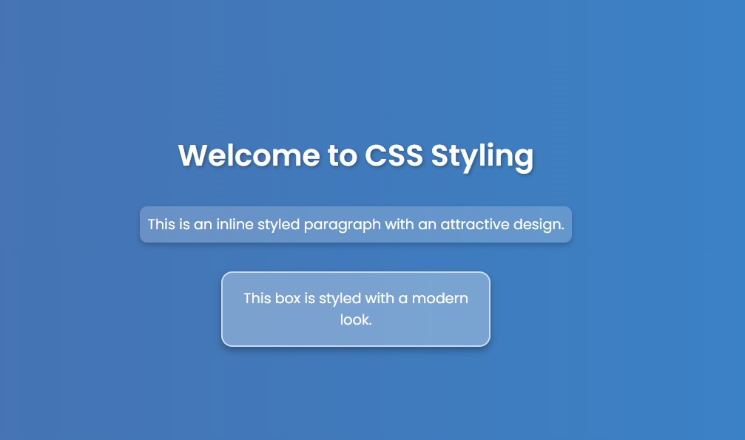

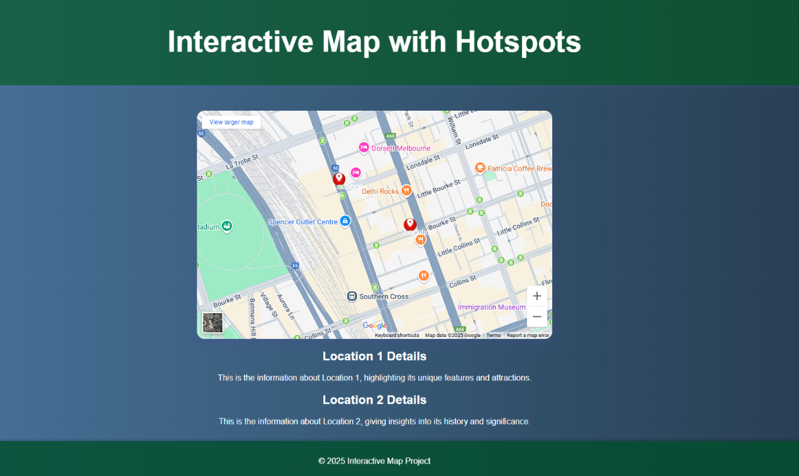

**Result:**

Thus the required web page has been successfully implemented using HTML and CSS.